

**HOSPITAL NETWORK DESIGN**

**PROJECT DOCUMENTATION**

**Name**:

SHAHZAIB

**Roll No**:

SU92-BSDSM-F22-006

**Program**:

BS DATA SCIENCE

**Section**:

5A

**Course**:

COMPUTER NETWORKING (LAB)

**Submitted to**:

**SIR RASIKH ALI**

**TABLE OF CONTENT**

|  |  |  |
| --- | --- | --- |
| **SNO** | **TITLE** | **PAGE** |
| 1 | Abstract | 3 |
| 2 | Network Requirements | 3 |
| 3 | Hospital Segments | 3 |
| 4 | Features and Services | 4 |
| 5 | Cost of Network | 4 |
| 6 | Configuration | 5 |
| 7 | Definitions |  |
| 8 | Network Diagram |  |
| 9 | Conclusion |  |

**ABSTRACT**

This report describes the network design of Health care management or Hospital. In this network topology the nodes (i.e., computers, switches, routers or other devices) are connected to a local area network (LAN) and network via links (twisted pair copper wire cable or optical fiber cable). We have used Cisco Packet Tracer for designing the network topology It’s a general design which can be implemented at any higher level to manage network system.

**NETWORK REQUIREMENTS**

In Health care Network topology, we have desktop Computer, laptops, smart phone. There is a data flow between the devices within the system. We have divided our network into segments like for Hospital wards, clinical area etc. We have also used SSH for security. Our network requirements include network devices like routers, switches, server.

**HOSPITAL SEGMENTS**

**1** General ward

**2** Private ward

**3** Clinical Area

**4** IT Department

**5** Entrance Reception

**FEATURES AND SERVICES**

**•** DHCP

**•** DNS

**•** Subnetting

**•** HTTPS

**•** SMTP

**•** FTP

**•** WIFI

**COST OF NETWORK**

* **Cisco Switch**

250$ Each

1250$ Cost of 5 Switch

* **Cisco Router**

350$ Each

2100$ Cost of 6 Router

* **Cisco Server**

400$ Each

800$ Cost of 2 Server

* **Computer Cost**

125$ Each

1500$ Cost of 12 Computer

**Total Cost = 5650$**

**CONFIGURATION**

The diagram is properly commented. We have divided the diagram into 6 segments as named above. Hospital Segments representing different departments of hospital. Following are the running configuration of routers and switches related to different segments of hospital respectively:

|  |  |
| --- | --- |
| **General Ward Switch** | **General Ward Router** |
|  |  |

|  |  |
| --- | --- |
| **Private Ward Switch** | **Private Ward Router** |
|  |  |

|  |  |
| --- | --- |
| **Clinical Area Switch** | **Clinical Area Router** |
|  |  |

|  |  |
| --- | --- |
| **IT Department Switch** | **IT Department Router** |
|  |  |

|  |  |
| --- | --- |
| **Entrance Switch** | **Entrance Router** |
|  |  |

**DEFINITIONS**

* **DHCP**

The Dynamic Host Configuration Protocol (DHCP) is a network management protocol used on UDP/IP networks whereby a DHCP server dynamically assigns an IP address and other network configuration parameters to each device on a network so they can communicate with other IP networks.

* **DNS**

The Domain Name System is a hierarchical and decentralized naming system for computers, services, or other resources connected to the Internet or a private network.

* **SUBNETTING**

A subnetwork or subnet is a logical subdivision of an IP network. The practice of dividing a network into two or more networks is called subnetting.

* **HTTPS**

Hypertext Transfer Protocol Secure is an extension of the Hypertext Transfer Protocol. It is used for secure communication over a computer network and is widely used on the Internet. Hypertext Transfer Protocol Secure is an extension of the Hypertext Transfer Protocol. It is used for secure communication over a computer network and is widely used on the Internet.

* **SMTP**

The Simple Mail Transfer Protocol is a communication protocol for electronic mail transmission.

* **FTP**

The File Transfer Protocol is a standard network protocol used for the transfer of computer files between a client and server on a computer network.

* **WIFI**

Wi-Fi is the name of a wireless networking technology that uses radio waves to provide wireless high-speed Internet and network connections.

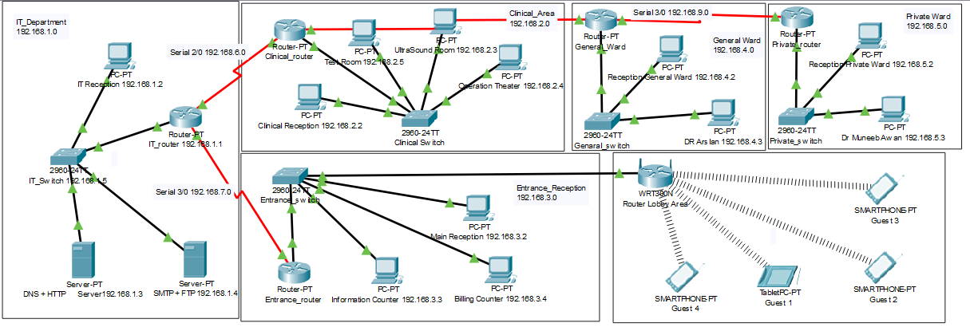**NETWORK DIAGRAM**

**CONCLUSION**

This report describes how we have designed network topology of hospital (Health care Management System). With VLSM for Subnetting, segmented the diagram into 5 segments. This topology can also be implemented on higher level of hospitals.